2 Types of Header and footer as follows

1. HEADER v1 - Displays in all pages
2. FOOTER v1 - Displays in all pages
3. HEADER v2 - Displays only in First page
4. FOOTER v2 - Displays only in Last page

**1 - HEADER v1 - Displays in all pages**

In adobe forms layout create subform layout and place the text as follows

It should be in **MASTER PAGE** section

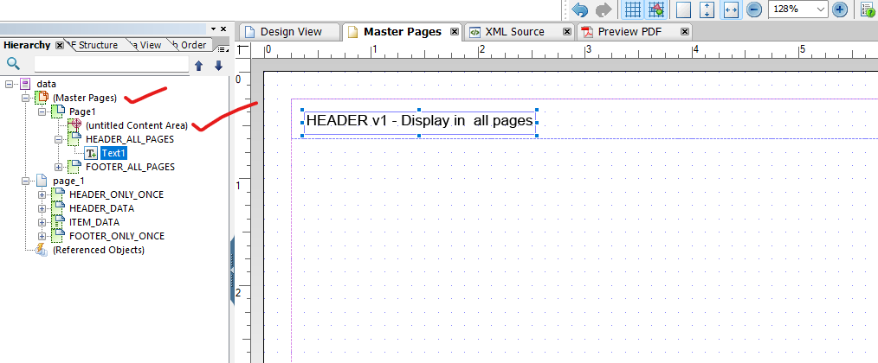

**2 - FOOTER v1 - Displays in all pages**

It should be in **MASTER PAGE** section

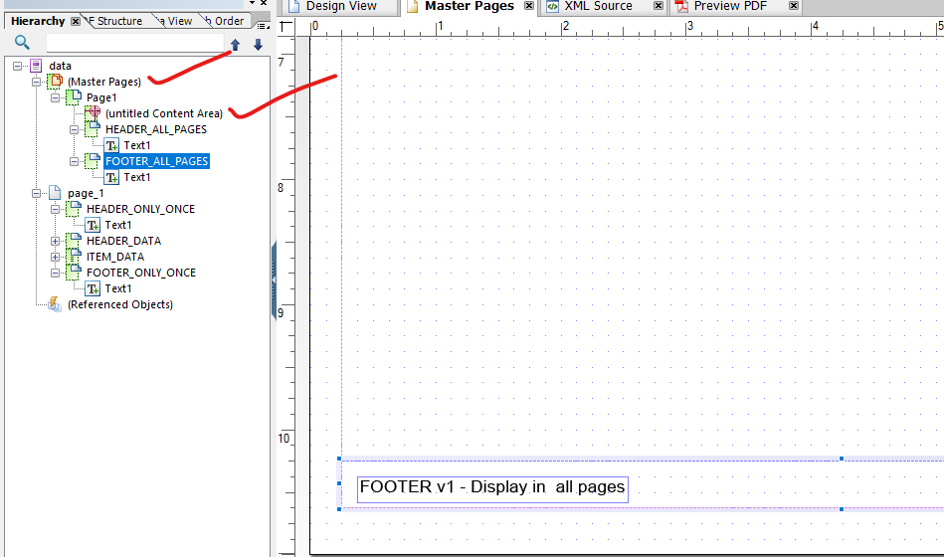

Now notice the object name **“(Untitled Content Area)”** it needs to be adjusted

or else the header and footer text will be overlapped by line items as follows

First page header will appear correctly

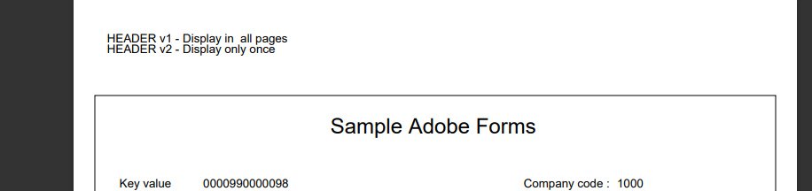

First page footer will appear correctly

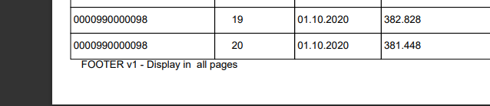

Second page Header

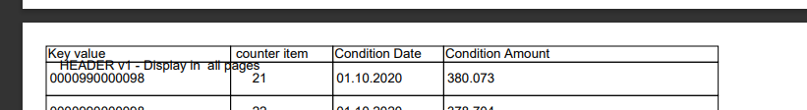

Second page Footer

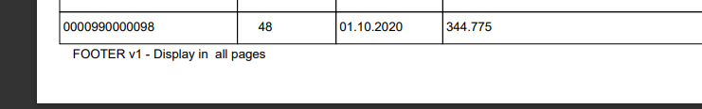

Third page Footer

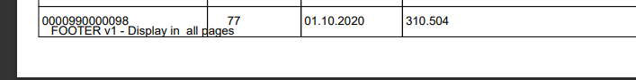

TO Avoid the above problem **“(Untitled Content Area)”** needs to be adjusted in the layout as follows

“Untitled content area” renamed as MAIN (for short representation)

IN TOP SIDE adjust like this (in layout HEADER BLOCK SHOULD BE OUTSIDE MAIN)

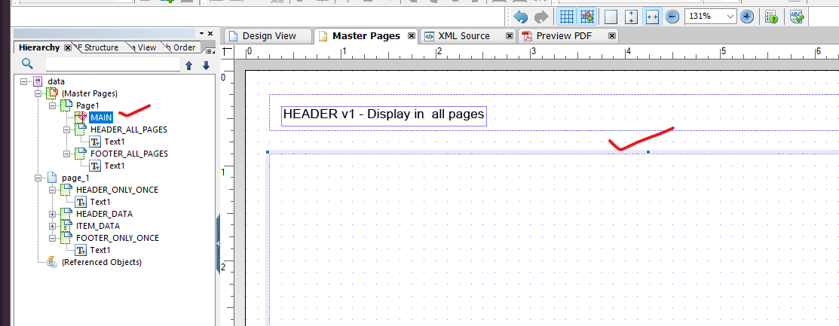

IN BOTTOM side adjust like this (in layout FOOTER BLOCK SHOULD BE OUTSIDE MAIN)

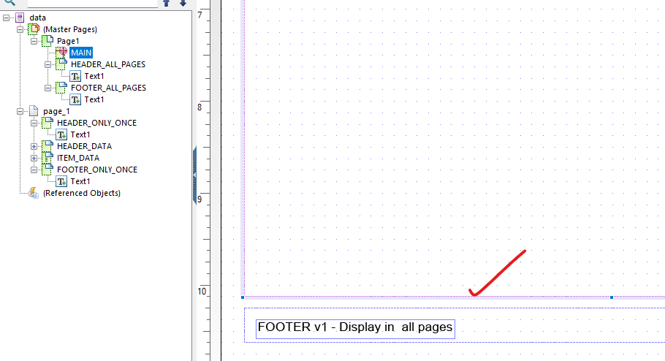

**MASTER page is a section where what ever object is placed it will be displayed in all the pages throughout adobe forms mostly (LOGO and TITLES) are placed in this sections**

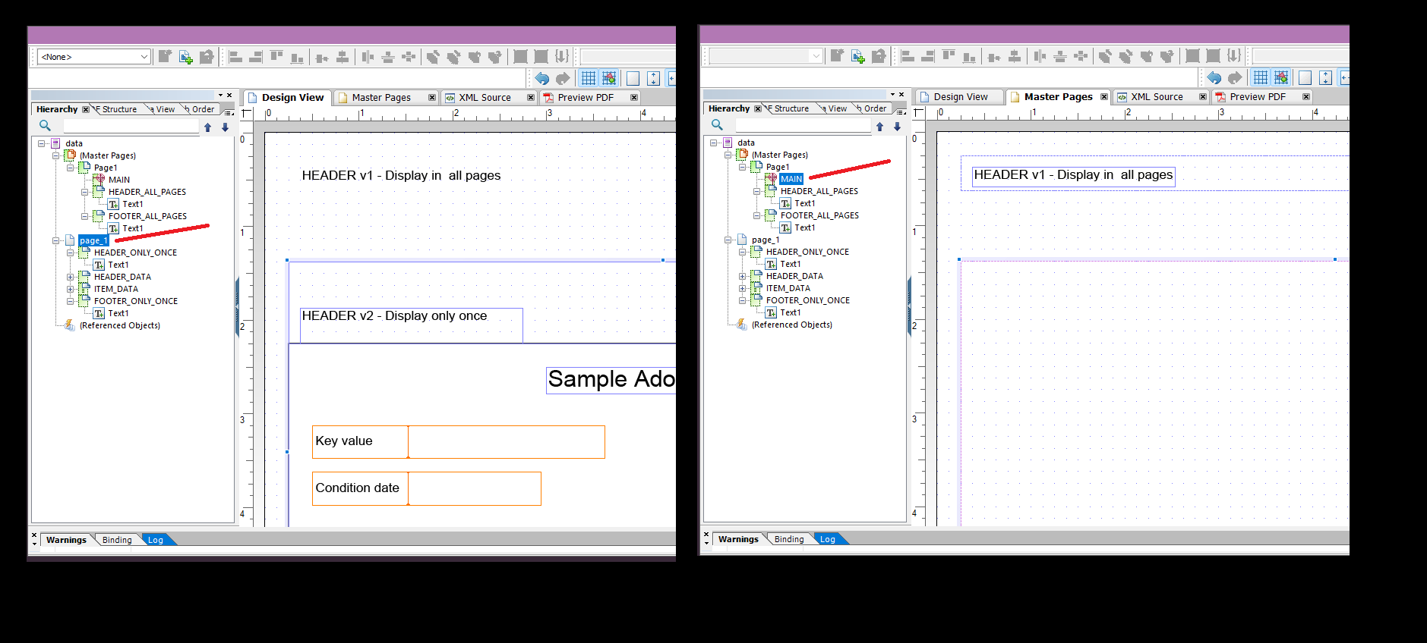

In the above image there is a comparison between layout just to point out that

**MAIN layout object of the MASTER PAGE section is representing the PAGE_1 section**

Objects of the PAGE_1 sections are not repeated it is displayed only once it is the area where LINE_ITEMS are processed and LOOPED for display

**3 - HEADER v2 - Displays only in FIRST page**

**4 - FOOTER v2 - Displays only in LAST page**

Both the HEADER and FOOTER which needs to be displayed only once is placed in PAGE_1 section

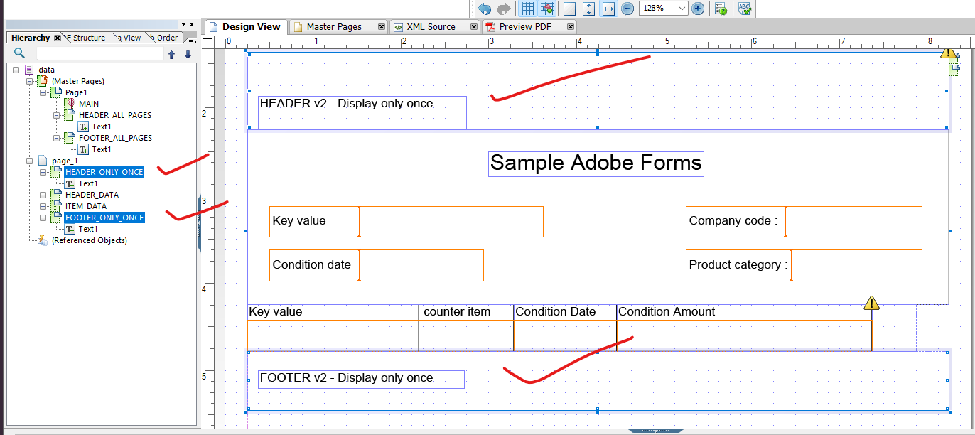

* header should be placed above line items sub form layout
* footer should be placed below line items sub form layout

sample of ADOBE FORMS with header and footer with v1 and v2 types displayed as follows

Footer display

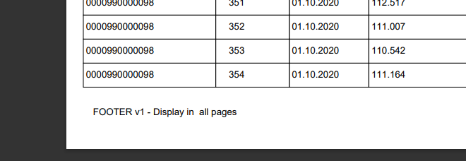

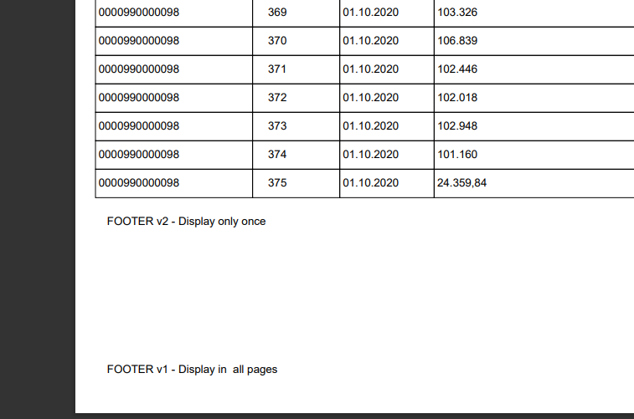

Header Display

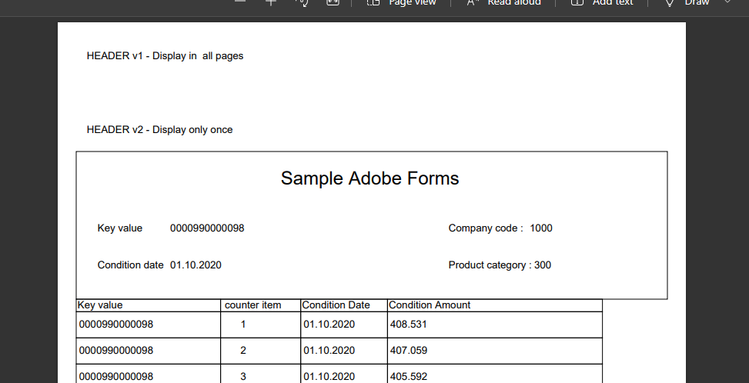

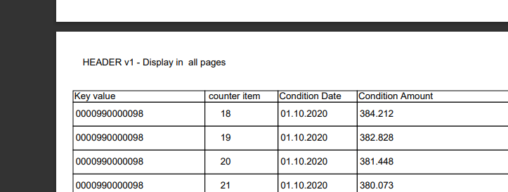

Sample attachment of pdf file for reference



SFP ADOBE FORM LAYOUT FILES

